Lab 5

1.

a. The independence assumption enables us to estimate the variance of the difference of means, the test statistics of t test will follow t distribution, and therefore we can do the inference procedure.

In this study, students and staff are in the same school but they are selected randomly, so they may be in different classes/departments and may not be related. There is also a very small chance they are genetically related.

b. Homogeneous variance enables us to pool the variance and therefore we will have more information to estimate the variance.

In this study, we have equal sample size for both groups, so the estimated variance stays the same. Therefore, even if homogeneous variance is violated, it does not have much effect.

c. Normal distribution makes sure that the test statistics follow t distribution.

In this study, we have equal sample size, and we can plot q-q plots to see if the data has similar distribution shapes.

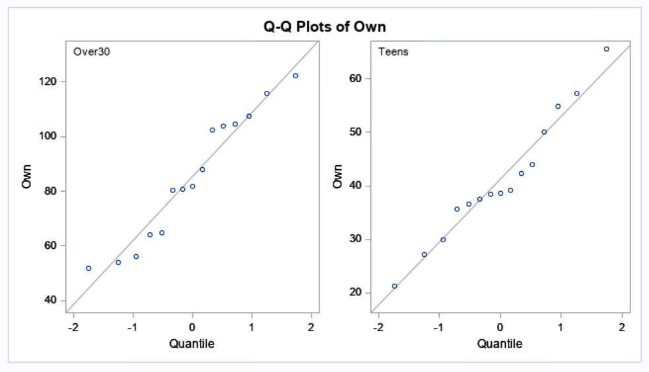

2.

W = 66, pvalue = 0.0019